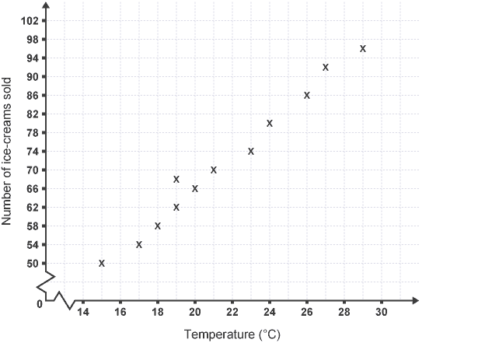
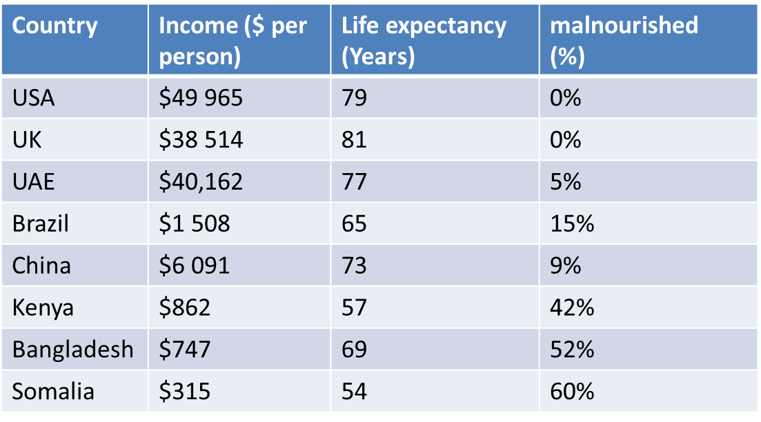
Graphing the relationship between Income and Health
The USA, UK, UAE, Brazil and China are all possible superpower countries. Use the AF1 success criteria to accurately draw a scatter graph to find a correlation between income and life expectancy.

AF1:  Essential Features | W.W.W  (Included and accurate) | E.B.I  (Aim to include or improve next time) | Overall Grade | Date:  Sign:
Title |  |  | Teacher comment:
Accuracy
Key
Presentation
Axis

