Mapping Uganda
Use the success criteria, the maps and an
atlas to accurately map Uganda.

____________________________________

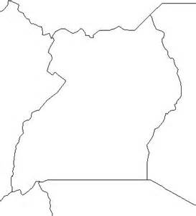
Mark the following on to your outline map.
HUMAN GEOGRAPHY (man made)
- The cities of San Francisco, Los Angeles
- The state capital of Sacramento.
- States of California and Nevada and the country of Mexico
PHYSICAL GEOGRAPHY (natural)
- Death Valley
- Mt. Whitney
- Pacific Ocean
- Mojave Desert
Better maps will have a key (like above), so the map stays clear; add a title and a north arrow.

__________________________

AF2: Map  Essential Features | W.W.W  (Included and accurate) | E.B.I  (Aim to include or improve next time) | Mark  /10 | Date:  Sign:
Title |  |  | Teacher comment:
Height
Accuracy
Key |  | Parent Comment:
Scale |  |  | Student comment:  Parent Comment:
Direction
Presentation

