Describe the location of Uganda and Katikamu.
Use the success criteria, the maps and an atlas to accurately describe the location of Uganda and the town of Katikamu.
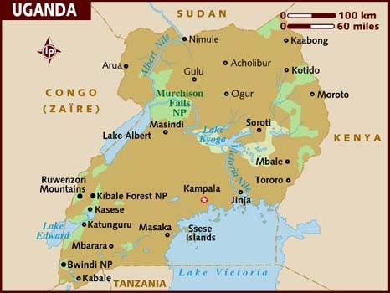

Key
- Katikamu

…………………………………………………………………………………………………………………………………………………………………….…………….
…………………………………………………………………………………………………………………………………………………………………….…………….
…………………………………………………………………………………………………………………………………………………………………….…………….
…………………………………………………………………………………………………………………………………………………………………….…………….
…………………………………………………………………………………………………………………………………………………………………….…………….
…………………………………………………………………………………………………………………………………………………………………….…………….
…………………………………………………………………………………………………………………………………………………………………….…………….
…………………………………………………………………………………………………………………………………………………………………….…………….
…………………………………………………………………………………………………………………………………………………………………….…………….
AF3:  Essential Features | W.W.W  (Included and accurate) |  |  | E.B.I  (Aim to include or improve next time) |  | Mark  /10 | Date:  Sign:
Continents |  |  |  |  |  | Teacher comment:
Country
Coordinates
Place
Direction
Scale
Student comment: |  |  |  |  | Parent comment:
…………………………………………………………………………………………………………………………………………………………………….…………….
…………………………………………………………………………………………………………………………………………………………………………………..

