Energy Demand in Ethiopia

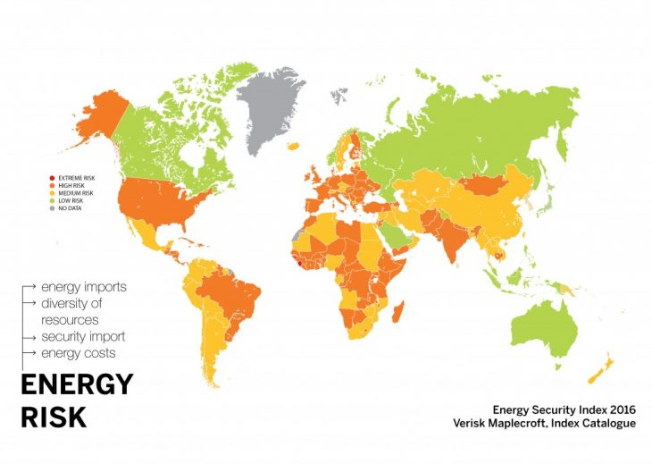

Ethiopia is ranked 172 out of 189 countries on the Human Development Index (HDI). This means it has a low level of development (developing country).

It suffers energy insecurity. This means that it does not have enough access to energy supply in order to meet demand.

High risk

**Reasons for energy insecurity**



Ethiopia’s main energy source are based on Biomass and waste products, generating 92% of its total electricity. The rest of the energy is made by oil (6%) and hydropower (2%). This is called the Energy Mix.

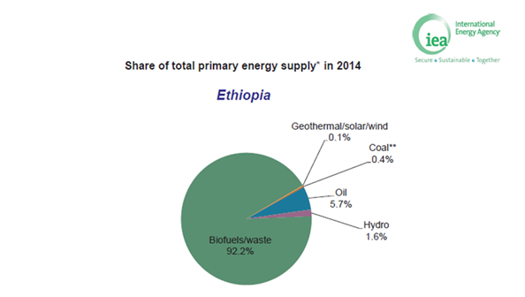



Factors that impact on energy supply:

Factors that affect energy supply can be political, technological, physical (natural) or economic (money). In Ethiopia some factors that affect energy supply are:

* **Political and Technological** = The country has seen a shift towards the secondary sector, as Transnational Cooperation’s such as GAP has relocated factories due to cheap labour and large pool of workforce. This has led to a greater use of machines to manufacture textiles and therefore increasing energy demand by a staggering 14%.
* **Economic** = Ethiopia is one of the least developed countries in the world. 34% (over 100 million inhabitants) live below the poverty line and therefore cannot afford energy. This means the country has one of the lowest rates of access to modern energy services because of limited money to purchase scarce/ expensive fossil fuels.
* **Economic** = Ethiopia hosts 10 large rivers including Blue Nile and Omo. This means it has potential to generate over 45,000MW by using Hydroelectric power, which is the 2nd highest in Africa but the set up costs make it economically difficult.



**Saudi Arabia eyes Ethiopian hydropower link to cut reliance on oil and gas**

**The Gulf Cooperation Council’s grid operator is studying the feasibility of a cable to Ethiopia, which would run through currently war-torn Yemen.**

**Arabian Gulf countries are considering an electricity link with Ethiopia to import hydropower, according to the region’s grid operator.**

The Gulf Cooperation Council Interconnection Agency (GCCIA) is studying the feasibility of a cable – which would pass through currently warn-torn Yemen – as part of efforts to reduce reliance on oil and gas for power generation.

Connections with Africa and Europe, as well as homegrown renewable energy projects, will help to save petroleum for export, GCCIA chief executive Ahmed Ali Al-Ebrahim told Climate Home News.

“We are rich in energy, we are dependent on fossil fuels, on gas and oil in the GCC countries,” he said. “But we cannot continue to rely on oil and gas for our energy production because it is also one of our main income sources.

“There is a general approach to diversify our power resources. That is why we are looking at renewable energy, nuclear energy and even hydropower in this case.”

A high-level delegation from Saudi Arabia [visited](https://www.middleeasteye.net/news/egyptian-gulf-relations-take-new-dip-after-saudi-delegation-visits-ethiopia-dam-30425904) the construction site of the Grand Ethiopian Renaissance Dam in 2016. In May, Ethiopia’s new prime minister Abiy Ahmed [made Riyadh his first calling point](http://www.africanews.com/2018/05/18/ethiopia-pm-in-saudi-arabia-first-official-trip-outside-africa/) after African neighbours Sudan, Kenya and Djibouti.

With a capacity of [6.45 gigawatts](https://allafrica.com/stories/201702280364.html), Ethiopia’s mega-project is set to be the largest hydropower dam in Africa. Building [could be completed as soon as 2019](https://www.egyptindependent.com/65-gerds-construction-completed-ethiopian-ambassador-sudan/). The reservoir will take another 5-15 years to fill.

The cable being explored would pass under the Red Sea and through Yemen to connect the resource to Saudi Arabia, said Al-Ebrahim.

Riyadh and its allies in the GCC are involved in the war in Yemen, having killed thousands of civilians in air strikes, [according to the UN](https://www.ohchr.org/EN/NewsEvents/Pages/DisplayNews.aspx?NewsID=23479&LangID=E).

“At the GCC we believe this conflict will end eventually, it is just a matter of time,” said Al-Ebrahim. “When the conflict finishes then there will be a big need for electric power in Yemen and beyond… We are hoping that by that time we will be ready with our plans and designs for this project.”

The feasibility assessment will take around two years, he added. The GCCIA is also considering electricity interconnectors with Jordan, Egypt and Iraq, and through them Turkey and Cyprus or Greece.

Ethiopia’s hydropower is attractive because it could balance intermittent generation from solar plants and stabilise the grid, Al-Ebrahim explained. Meanwhile a link to Europe could switch between import and export according to seasonal demand.

The Ethiopian megadam is politically sensitive, with Egypt in particular [raising concerns](https://www.climatechangenews.com/2017/07/18/egypt-faces-water-insecurity-ethiopian-mega-dam-starts-filling/) about the impact on river flows down the Nile. Its chief engineer Simegnew Bekele was shot dead in July, prompting [scenes of public mourning](https://www.bbc.co.uk/news/world-africa-44981490).

Researchers [have warned](https://www.nature.com/articles/s41560-017-0037-4) that many dams under construction in eastern and southern Africa are at risk of disruption from drought, as climate change makes rainfall more variable.

🅶🅴🅾🅶🆁🅰🅿🅷🆈 🅸🅽 🆃🅷🅴 🅽🅴🆆🆂

**Published by Climate Home news 27/09/2018, 2:51pm**

# *As a Dam Rises in Ethiopia, Its Manager Is Found Dead*

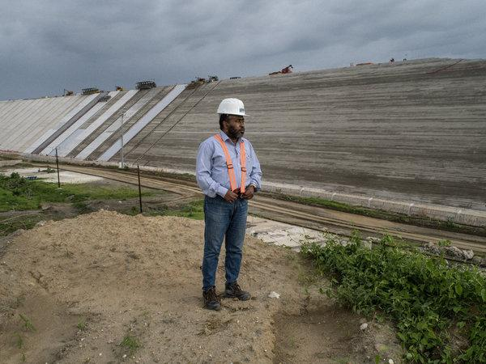

CAIRO — The manager of a $4 billion dam under construction on the Blue Nile River in Ethiopia was found shot dead on Thursday, drawing an anguished reaction from Ethiopia’s leaders and setting on edge one of Africa’s most contentious development projects.

The project manager, Semegnew Bekele, who was overseeing the construction of the Grand Ethiopian Renaissance Dam, was found slumped behind the wheel of his Toyota Land Cruiser in Meskel Square in the capital, Addis Ababa, at 8:30 a.m. He had a gunshot wound to his head, the federal police commissioner, Zeinu Jamal, told reporters.

The police also found a pistol inside the car and were trying to identify its owner, Mr. Jamal said. The police commissioner did not say whether he suspected foul play, fueling speculation that the death was linked to Mr. Semegnew’s work.

When completed, [the giant Renaissance dam](https://www.nytimes.com/2014/10/12/world/dam-rising-in-ethiopia-stirs-hope-and-tension.html?module=inline) is expected to generate 6,400 megawatts of hydroelectricity that will more than double Ethiopia’s current production and potentially allow the country to earn hundreds of millions of dollars in energy export revenues. But the project has met with stiff resistance from Egypt, where many fear it will cut into the country’s already strained supply of Nile water.

**Published by New York Times 28th July 2018**

🅶🅴🅾🅶🆁🅰🅿🅷🆈 🅸🅽 🆃🅷🅴 🅽🅴🆆🆂

FUTURE for Ethiopia’s energy mix



* Since 2011, Ethiopia has implemented the Climate- Resilient Green Economy (CRGE) strategy, which encourages us of clean energy sources like hydropower, wind, geothermal, solar and biomass, and implementing energy-efficient technologies in the transport and industrial sectors.
* Its 2010 Growth and Transformation Plan I (GTP-I), Ethiopia aimed to quadruple installed capacity by prioritising large hydro developments and achieving total power installed capacity of 10,000 MW by 2015.
* The government published the GTP-II for 2016-20, with the objective of reaching total installed capacity over 17,208 MW. Hydropower is set to make up about 90 per cent of the power supply.
* Gibe III, the tallest roller-compacted concrete (RCC) dam in the world, with 246 m dam height and 630 m crest length, was installed in December 2016. The USD 1.8 billion construction was financed 40 per cent by the Ethiopian Government, and 60 per cent by the China Exim Bank.

<https://www.hydropower.org/country-profiles/ethiopia>

