Coastal erosion and landforms– Flamborough Head
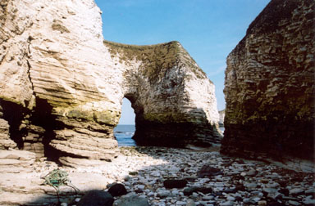
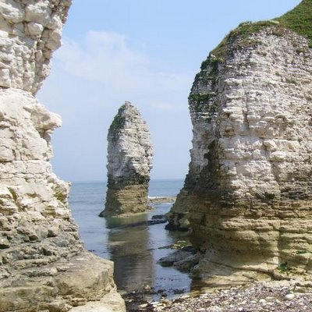
Chalk arch at Flamborough Head
Chalk stack at Flamborough Head

Flamborough Head is located at the Northern Point of the Holderness Coast in Yorkshire, North East England.
The hard chalk rocks in the area have protruded into a headland from the softer clays and glacial till surrounding it.
The headland has been attacked by the waves and has eroded over time due to hydraulic action and abrasion. Faults have developed into caves some of which have eroded through into arches. Stacks and stumps are also all present in this one beautiful area.

Flamborough head attracts a large number of tourists to this area; it is one of the UK best examples of arches, stacks and stumps. It provides jobs in local cafes and souvenir shops along with hotels. There is also a large number of bird species which nest in the cliffs which attract keen bird watchers.
However the jobs created are only seasonal and the winter months see a drop in local business usage. Local walkers are also straying from the paths which are damaging farmers’ crops. Finally parking became a problem for local people as tourists parked along the road. Double yellow lines have now been put up along with a car park for tourists and a better bus service from the train station. The car park is pay and display and the money raised is being used to create proper footpaths and cycles paths which are clearly marked ensuring that tourists stick closely to these and do not damage land close by.

Case study question:
1. Name and locate a landform created by coastal erosion. 2. Describe the impact it has on the local area. 3. Explain how it was formed.
Describe the location of Flamborough Head.

Describe the landforms found there.

Explain the formation of the landforms, use a diagram if you wish

Explain the positive and negative impacts of the landforms on the local area

Explain how they are trying to manage the landforms sustainably

Five key questions – complete using case study sheet and your own knowledge.

Case study of coastal erosion and management – The Holderness Coast
The Holderness Coast is located on the North-East coast of England; it is one of the fastest eroding coastlines in Europe due to its soft geology.
The soft boulder clay that makes up most of the area is easily eroded and then the material is transported southwards due to long shore drift. This has led to the formation of Spurn head at the mouth of the Humber. Towards to North of the coastline Flamborough head is make up of harder chalk as many attractive landforms of erosion are found here.

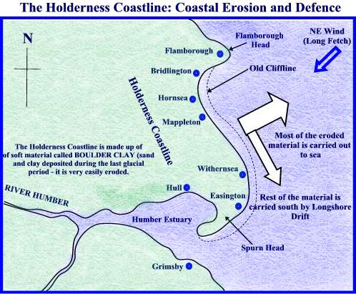

All along the coast homes and land is being lost to the sea. Some areas have been left to managed retreat but many areas where there are towns and industries are being protected using coastal defences.
The village of Mappleton is greatly underthreat by coastal erosion along the coastline today the main road is only 50m from the edge. To reduce the amount of erosion threatening Mappleton, 2 rock groynes were constructed in 1991 to encourage the build up of beach in front of Mappleton by trapping longshore drift. This meant that that waves would break on the beach rather than attacking the cliffs. However those living south of Mappleton village have experienced the 'knock-on' effects of the coastal management.
The town of Withernsea has been protected with large rocks (revetments) shipped in from Norway. They take the force of the waves protecting the land behind. The area is protected as it is a major tourist town. They have also built a sea wall at the back of the beach. This has been made into a promenade but has also meant to beach in front is getting washed away.
The gas plant at Easington is being protected by revetments similar to those in Withernsea. These are very effective as ensuring the gas plant does not end up in the sea.

Spurn Head is a spit created by deposition. Behind this spit is large salt marsh which contains many race species. As the management methods up the coast have been put in place less sediments is getting down to replace the sand on the spit. Groynes have been put in place to ensure the spit is safe and the marsh behind remains.

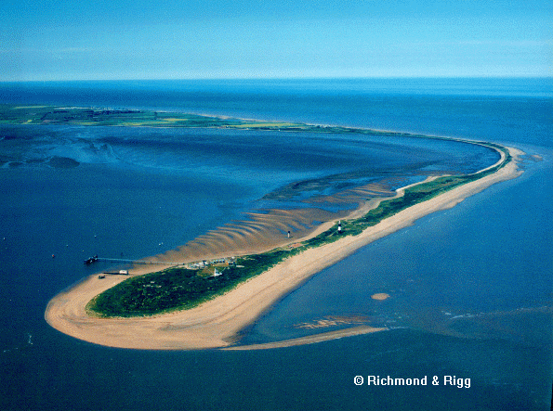
Five key questions – complete using case study sheet and your own knowledge.

Describe the location the Holderness Coast and outline its geology

Describe the physical processes at work along the coastline.

Describe the methods of coastal management used along the coast.

Explain the positive impacts this has had.

Explain the negative impacts this has had.

