Fact file  Africa | 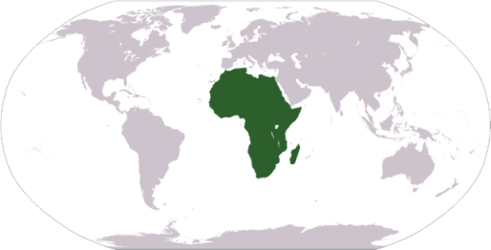 |  | Fact file  Asia | 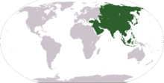
Size: |  |  | Size:
Population: |  |  | Population:
Number of countries: |  |  | Number of countries:
Largest country: |  |  | Largest country:
Smallest country: |  |  | Smallest country:
Oceans: |  |  | Oceans:
Ethnic groups: |  |  | Ethnic groups:

Fact file  Europe | 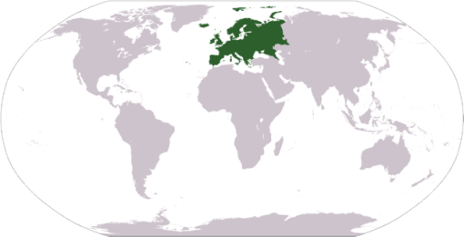 |  | Fact file  North America | 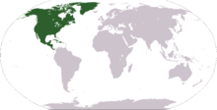
Size: |  |  | Size:
Population: |  |  | Population:
Number of countries: |  |  | Number of countries:
Largest country: |  |  | Largest country:
Smallest country: |  |  | Smallest country:
Oceans: |  |  | Oceans:
Ethnic groups: |  |  | Ethnic groups:

Fact file  South America | 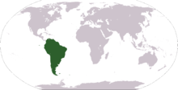 |  | Fact file  Oceania | 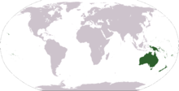
Size: |  |  | Size:
Population: |  |  | Population:
Number of countries: |  |  | Number of countries:
Largest country: |  |  | Largest country:
Smallest country: |  |  | Smallest country:
Oceans: |  |  | Oceans:
Ethnic groups: |  |  | Ethnic groups:

Fact file  Antarctica | 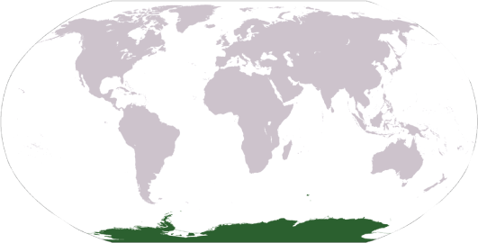
Size:
Population:
Number of countries:
Largest country:
Smallest country:
Oceans:
Ethnic groups:

