Key ideas  Paper 2: Human Geography - Economic Activity and Energy | Content | Start of topic |  |  |  | End of topic
Review the list below and rank your confident level for each. R- not confident A- slight confident G- very confident |  | R | A | G |  | R | A | G
4.1 The relative  importance of  different economic  sectors and the  location of economic  activity varies  spatially, and  changes over time | Classification of employment by economic sector (primary,  secondary, tertiary and quaternary) and the
 | Explain reasons for the differences in the employment structures in countries at different levels of development (Clark Fisher Model).
Factors affecting the location of economic activity in each
economic sector and how these factors can change over time.
Reasons for the changes in the numbers of people employed in
each economic sector, including the availability of raw
materials, globalisation, mechanisation, demographic changes
and government policies.
4.2 The growth and  decline of different  economic sectors has  resulted in a range of  impacts and possible  resource issues | CASE STUDY - Positive and negative impacts of economic sector shifts in a named developed country – UK.
 | CASE STUDY - Positive and negative impacts of economic sector shifts in a named developing country – Ethiopia
 | Informal employment: causes (economic development, rural-urban migration) and characteristics (advantages and disadvantages) in a named Megacity: Addis Ababa
 | Different theories (Malthus and Boserup) are used to explain the relationship between population and resources.
4.3 Countries  increasingly  experience an energy  gap and therefore  seek energy security  by developing a  balanced energy mix  and sustainable  energy use | Energy demand and production varies globally and is affected by a range of factors: population growth, increased wealth and technological advances.
Non-renewable, e.g. coal, oil, natural gas, uranium and shale gas/oil, and renewable sources of energy, e.g. solar, wind, hydroelectric power (HEP), geothermal, biomass, have advantages and disadvantages for people and the
environment.
Energy can be managed in a sustainable way through
education, efficiency and conservation (within industry,
transport and the home).
Write down the keywords you use in this topic:
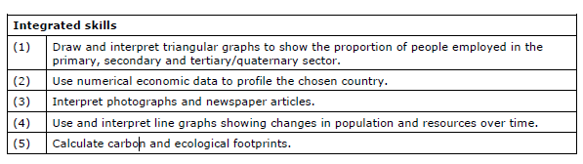

Paper 1 – Physical Geography
Coastal Environments checklist

