Student activity:
- Cut out the following top trump cards and read the information about the different types of extreme weather.
- Rank the cards from most extreme weather event to least extreme weather event.

Flooding |  |  | Hail storm |  |  | Ice storm
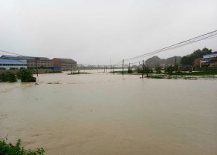 |  |  | 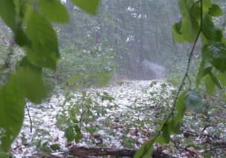 |  |  | 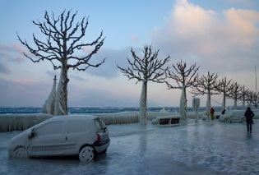
Heavy rain causes rivers to overflow. |  |  | It’s raining ice! |  |  | A winter storm that covers everything in ice!
Number killed: |  | 4 million in China, in 1931 | Number killed: |  | 0 | Number killed: |  | 0
Places affected: |  | Most countries in the world | Places affected: |  | Every continent | Places affected: |  | Mainly USA and Canada. We can have them too!
Most expensive event cost: |  | China, 1998 $30 billion | Most expensive event cost: |  | Minnesota 2017 cost $2.5 billion
 |  |  |  |  |  | Most expensive event cost: |  | USA South East freeze cost $1 billion
Highest flood level: |  | 47.8 ft | Largest hail recorded: |  | 17.8cm in diameter
Hurricane |  |  | Lightning |  |  | Monsoon
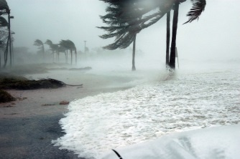 |  |  | 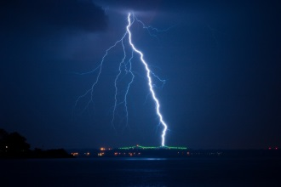 |  |  | 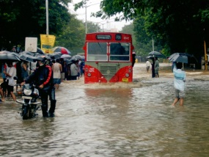
A strong storm with sustained wind speeds of over 74 mph. |  |  | A flash of electricity during a storm. |  |  | Very heavy rain during the rainy season in a tropical country.
Number killed: | Hurricane Mitch, in 1998 killed 11000 |  | Number killed: | 24000 people per year globally! |  | Number killed: | In 1983 in Thailand, 10000 people died
 |  |  | Places affected: | Africa is the continent that experiences the most. |  | Places affected: | Asia and northern Australia
Places affected: | Countries around the Atlantic, South Pacific, Indian Ocean, Gulf of Mexico and Caribbean |  |  |  |  | Most expensive event cost: | 2011, Thailand $45 billion
 |  |  | Most expensive event cost: | $5 billion per year just in the USA alone!
 |  |  |  |  |  | Monsoon fact: | This year alone 1.8 million children could not attend school due to the damage caused by the monsoon.
Most expensive event cost: | Hurricane Katrina cost $108 billion in 2005 |  | Lightning fact: | An area in North West Venezuela has 1.2 million lightning strikes per year! There can be as many as 280 per hour!
© Ranveig, 2006, commons.wikimedia.org/wiki/File:Bombay_flooded_street.jpg
Tornado |  | Heat wave |  | Drought
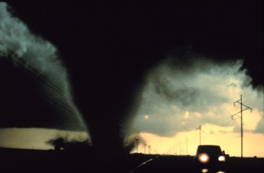 |  | 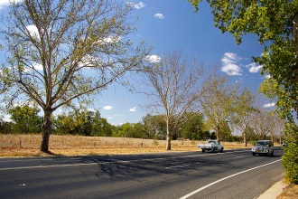 |  | 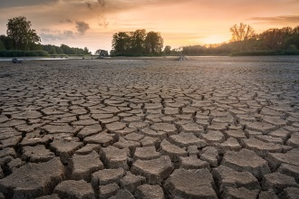
A fast spinning column of air |  | Prolonged period of abnormally hot weather. |  | A prolonged period of abnormally low rainfall, leading to a shortage of water.
Number killed: | The deadliest tornado occurred in 1989 in Bangladesh killed 1300 people. | Number killed: | In 2003 the European heat wave registered 70000 deaths (2000 in the UK) | Number killed: | The worst drought ever recorded killed over 400000 between 1983-1985 in Ethiopia.
Places affected: | Australia, Europe, Africa, Asia, and South America | Places affected: | Europe and North America | Places affected: | Every continent except Antarctica
Most expensive event cost: | Mid-west tornado, in 2017 cost $2.1 billion | Most expensive event cost: | £211 million per day for the UK! | Most expensive event cost: | Western USA $4.7 billion
Tornado fact: | The USA has about 1200 tornadoes per year and the fastest recorded speed was 318 mph. | Heatwave fact: | Heatwaves are becoming more common due to climate change. | Drought facts: | In Somalia, in 2017 110 people died in 48 hours due to drought.

©Bidgee, 2009, commons.wikimedia.org/wiki/File:Drought_and_heatwave_affected_London_Plane_Trees_(Platanus_×_hispanica).jpg

Explain your top and bottom choice by describing and explaining how the impacts will be different.
Don’t forget to use connectives (therefore, as well, in addition).
In your answer you need to explain your top choice and predict how the impacts will be different in an HIC or an LIC.

My type of extreme weather with the biggest impact is:
because

My type of extreme weather with the least impact is:
because

Their impacts will be different because:

Impact in a HIC | Impact in a LIC
How might people feel after experiencing one of these events?
Can you use named examples of countries or events?
Peer Assessment  – Types of extreme weather |  |  | Peer Assessment  – Types of extreme weather |  |  | Peer Assessment  – Types of extreme weather
WWW | Descriptor | EBI | WWW | Descriptor | EBI | WWW | Descriptor | EBI
 | You explained your choice of weather |  |  | You explained your choice of weather |  |  | You explained your choice of weather
 | You described the effects of this extreme weather |  |  | You described the effects of this extreme weather |  |  | You described the effects of this extreme weather
 | You have considered the long term / knock on effects |  |  | You have considered the long term / knock on effects |  |  | You have considered the long term / knock on effects
 | You have explained how the effects will be different in a HIC and a LIC |  |  | You have explained how the effects will be different in a HIC and a LIC |  |  | You have explained how the effects will be different in a HIC and a LIC
 | You have used key terms |  |  | You have used key terms |  |  | You have used key terms
 | You have used named examples and specific facts in support |  |  | You have used named examples and specific facts in support |  |  | You have used named examples and specific facts in support
 | Other: |  |  | Other: |  |  | Other:

