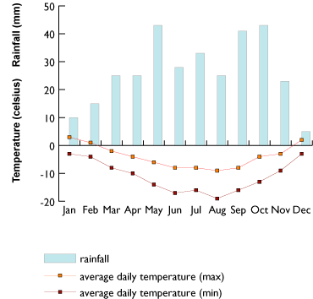
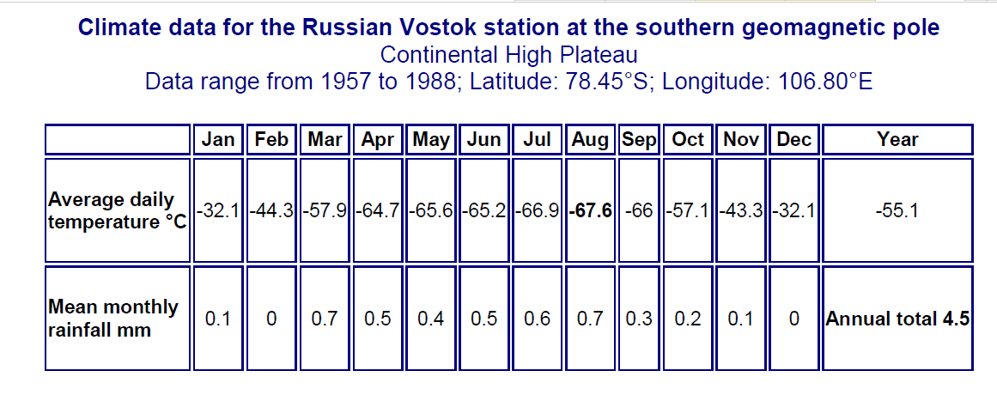
Graph 1: Your task is to draw a climate graph of Antarctica, so the scientists and building engineers can prepare fully for the task. It should look something like this…
Rainfall (mm)
AF1: Graphs  Essential Features | W.W.W  (Included and accurate) | E.B.I  (Aim to include or improve next time) | Overall Score  __ /5 | Date:  Sign:
Title |  |  | Teacher comment:
Accuracy
Key
Presentation
Axis |  |  | Student comment:
Peer comment:

Date | Number of tourists landing on Antarctica
2006 | 29,576
2007 | 33,054
2008 | 27,206
2009 | 21,622
2010 | 19,445
2011 | 22,122
2012 | 25,284
2013 | 27,735
2014 | 27,243
2015 | 30,369
2016 | 36,907
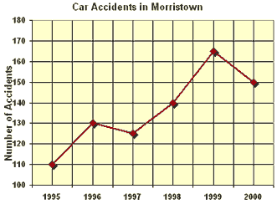
Graph 2: Scientists are interested in how many tourists are visiting Antarctica every year, so they can calculate if they are affecting the area. It should look something like this…

AF1: Graphs  Essential Features | W.W.W  (Included and accurate) | E.B.I  (Aim to include or improve next time) | Overall Score  __ /5 | Date:  Sign:
Title |  |  | Teacher comment:
Accuracy
Key
Presentation
Axis |  |  | Student comment:
Peer comment:

