Key ideas | Content | Start of topic |  |  |  | End of topic
Review the list below and rank your confident level for each. R- not confident A- slight confident G- very confident |  | R | A | G |  | R | A | G
3.1 Some places are  more hazardous than  others | What are the different types of natural hazards.
 | Distribution of hazards (tropical storms, earthquakes and Volcanoes)
Causes of volcanic and earthquake hazards, including the role
of plate boundaries and hotspots.
Causes of tropical cyclone hazards, including ocean
temperature, atmospheric pressure, wind shear and Coriolis
force.
3.2 Hazards have an  impact on people and  the environment | Reasons why people continue to live in areas at risk from  hazard events.
 | CASE STUDY: The shorter-term and longer-term impacts of one earthquake. Example:
 | CASE STUDY: The shorter-term and longer-term impacts of one Tropical Storm. Example:
 | CASE STUDY: The shorter-term and longer-term impacts of one Volcanic Eruption. Example:
3.3 Earthquakes present  a hazard to many  people and need to  be managed carefully  CASE STUDY: Hazard management for an earthquake in a developed country and a developing  Country. | CASE STUDY: Developing country - Nepal, 2015  Developed country – New Zealand, 2011
Preparation for earthquakes (warning and evacuation, building
design, remote sensing and GIS).
Short-term responses and relief (emergency aid, shelter and
supplies)
Longer-term planning (risk assessment, hazard mapping and
rebuilding programmes).
Write down the keywords you use in this topic:
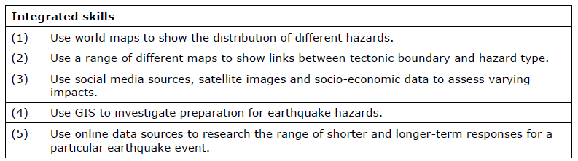
Paper 1 – Physical Geography
Hazardous Environments checklist

