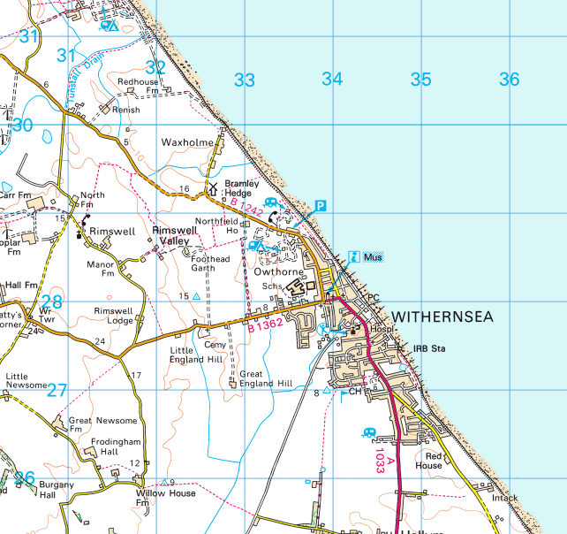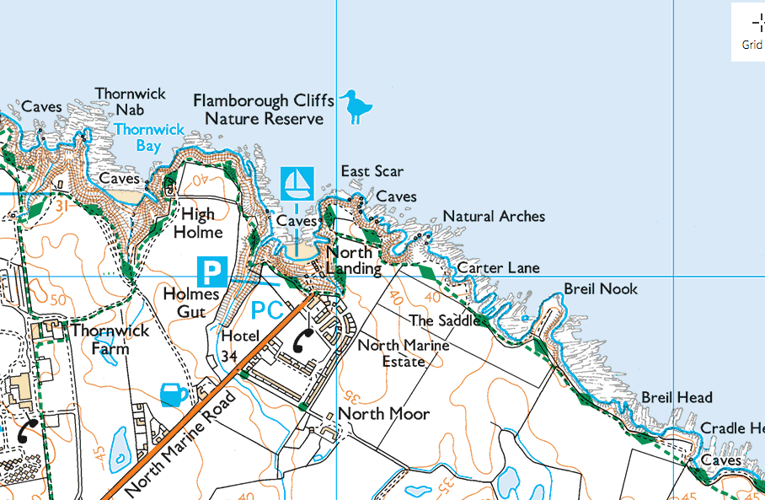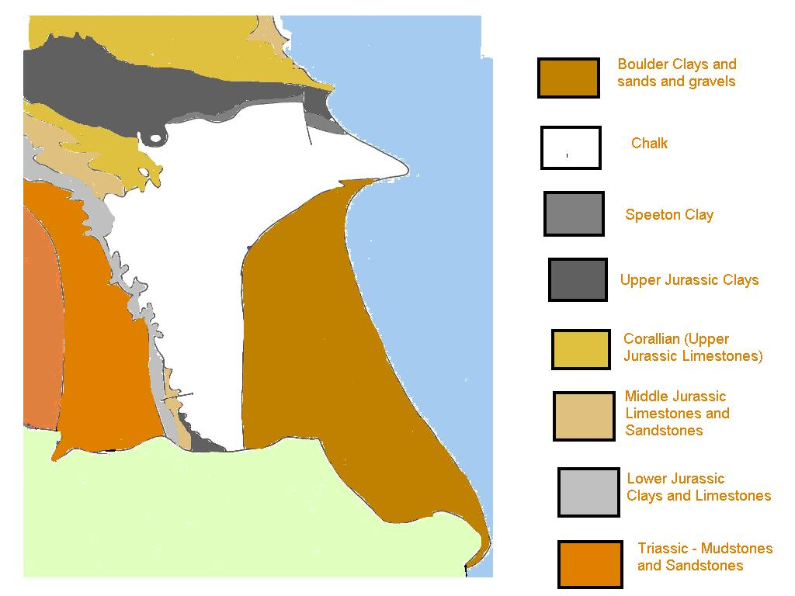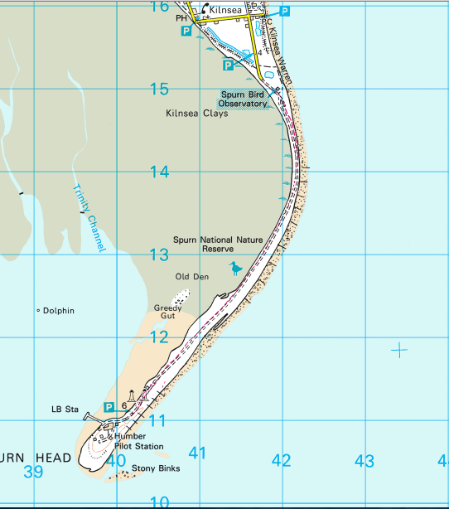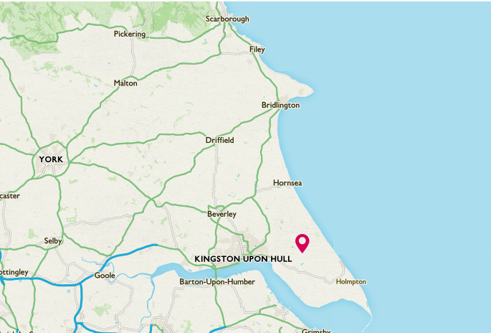

Landforms of deposition (map C)

1. What is the name of the landform shown in map C?
2. Describe the main features of this landform
3. On map C the scale is 1 grid square = 1km. Using this calculate the distance in km from x to Y
4. Give the four figure grid reference of the life boat station
5. Give the four figure grid reference of greedy gut
6. Give the six figure grid reference of the toilet (pc)
7. Give the six figure grid reference of the nature reserve
8. Describe how the shapes of the coastlines shown in maps D and E are different
9. What landforms of erosion are shown on map D?
10. What type of beach is shown on map E?
11. Give the four figure grid references of the grid squares with groynes in on map E
12. Give the six figure grid reference for the phone box in map D

Map E

Y

X

Map B

Describing Holderness

1. Using a map of the UK describe the location of the Holderness coastline
2. Study map A. Describe the main features of the Holderness coastline
3. Study map B. Use map A to explain why the coastline is shaped as is it

Map D

Map C

Map A

An example of a stretch of coastline in the UK

Holderness