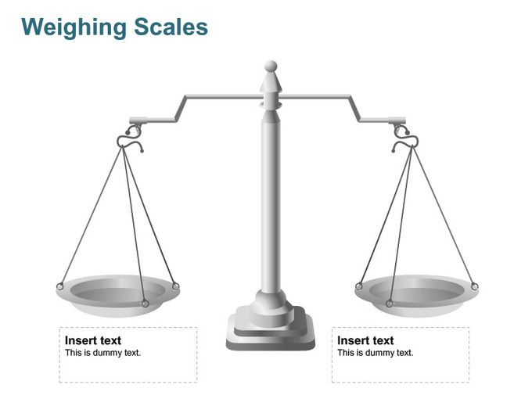

**Real life links – How do you use your mobile phone?**

**AF6: Keywords:**

**AF5: Benefits and costs of using mobile phones**

**Summary –** *Give your opinion – Do the benefits of mobile phones outweigh the cost? Can we learn to be more sustainable?*

**Negative impacts of using mobile phones**

*Use knowledge from the last series of lessons to list at least 5 problems of using mobile phones. Try and use evidence to support.*

**Benefits of using mobile phones**

*Use your new knowledge from today’s lesson to list at least 5 benefits of mobile phones. Make links to your own experiences. Try and use evidence to support.*