Spit  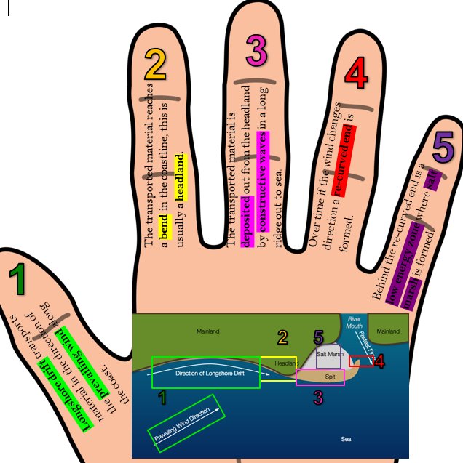 | Sequence – ________________________  __________________________________  __________________________________  Process – _________________________  __________________________________  Explanation – ______________________  __________________________________  __________________________________  __________________________________  __________________________________  __________________________________  __________________________________  Description – ______________________  __________________________________  __________________________________  __________________________________  __________________________________  __________________________________
Beach  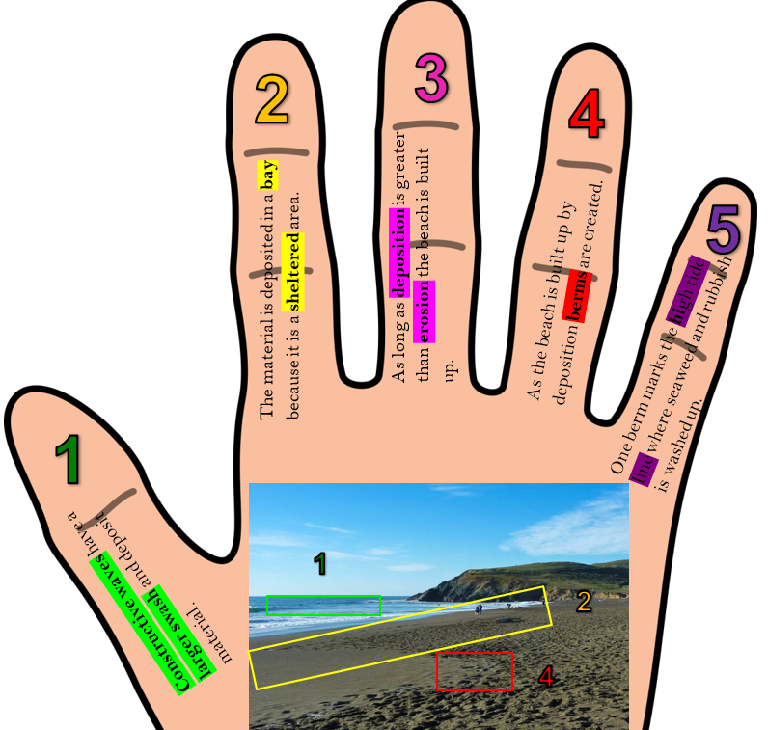 | Sequence – ________________________  __________________________________  __________________________________  Process – _________________________  __________________________________  Explanation – ______________________  __________________________________  __________________________________  __________________________________  __________________________________  __________________________________  __________________________________  Description – ______________________  __________________________________  __________________________________  __________________________________  __________________________________  __________________________________

Dune formation  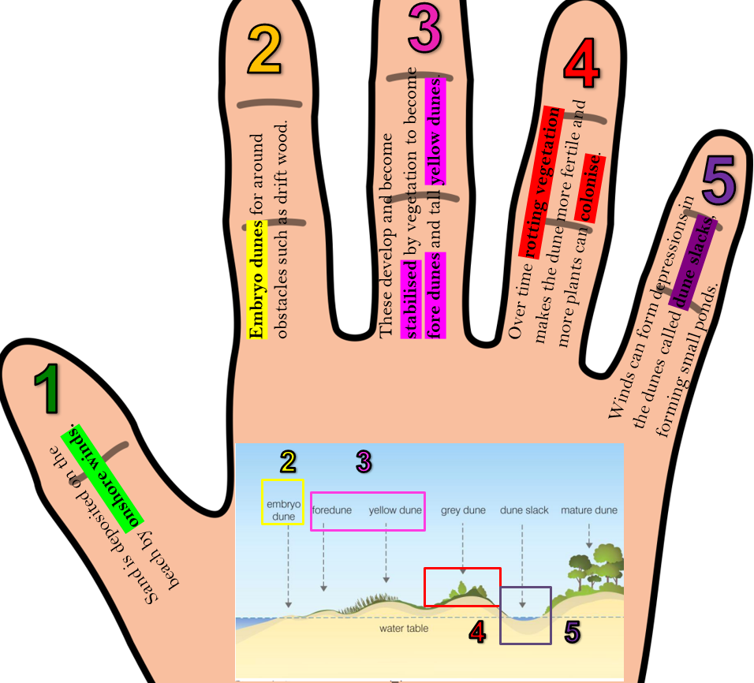 | Sequence – ________________________  __________________________________  __________________________________  Process – _________________________  __________________________________  Explanation – ______________________  __________________________________  __________________________________  __________________________________  __________________________________  __________________________________  __________________________________  Description – ______________________  __________________________________  __________________________________  __________________________________  __________________________________  __________________________________
Cliff formation  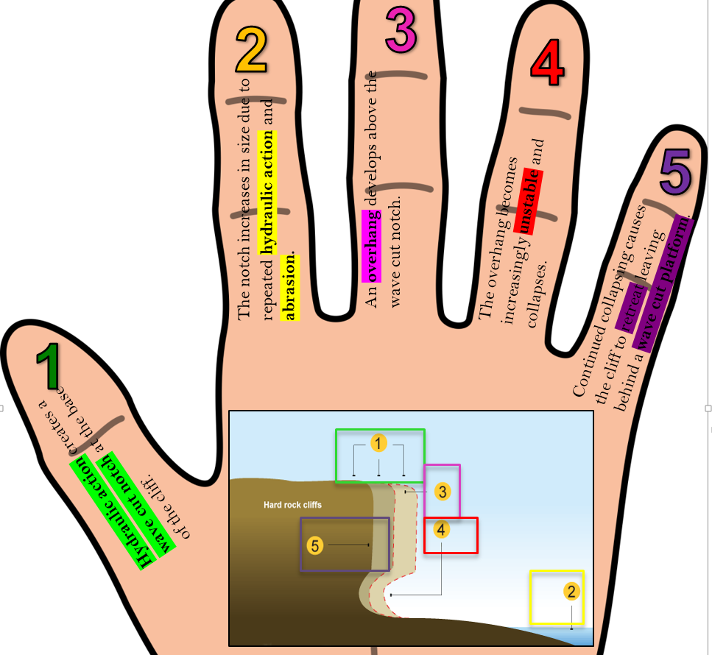 | Sequence – ________________________  __________________________________  __________________________________  Process – _________________________  __________________________________  Explanation – ______________________  __________________________________  __________________________________  __________________________________  __________________________________  __________________________________  __________________________________  Description – ______________________  __________________________________  __________________________________  __________________________________  __________________________________  __________________________________

Headlands and bays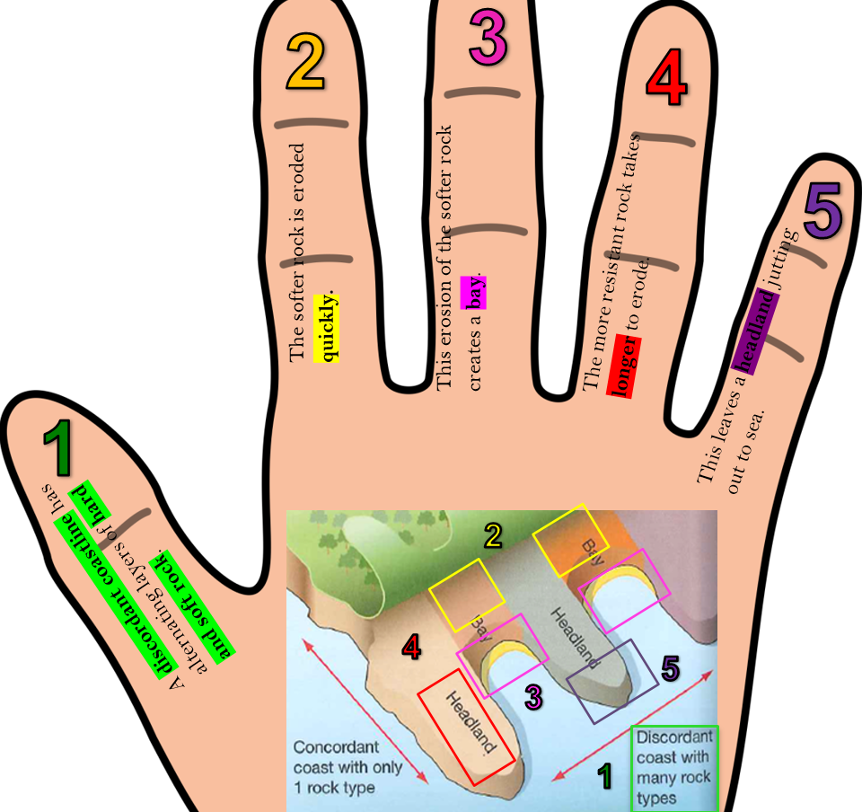 | Sequence – ________________________  __________________________________  __________________________________  Process – _________________________  __________________________________  Explanation – ______________________  __________________________________  __________________________________  __________________________________  __________________________________  __________________________________  __________________________________  Description – ______________________  __________________________________  __________________________________  __________________________________  __________________________________  __________________________________
Arches, Stacks and Stumps  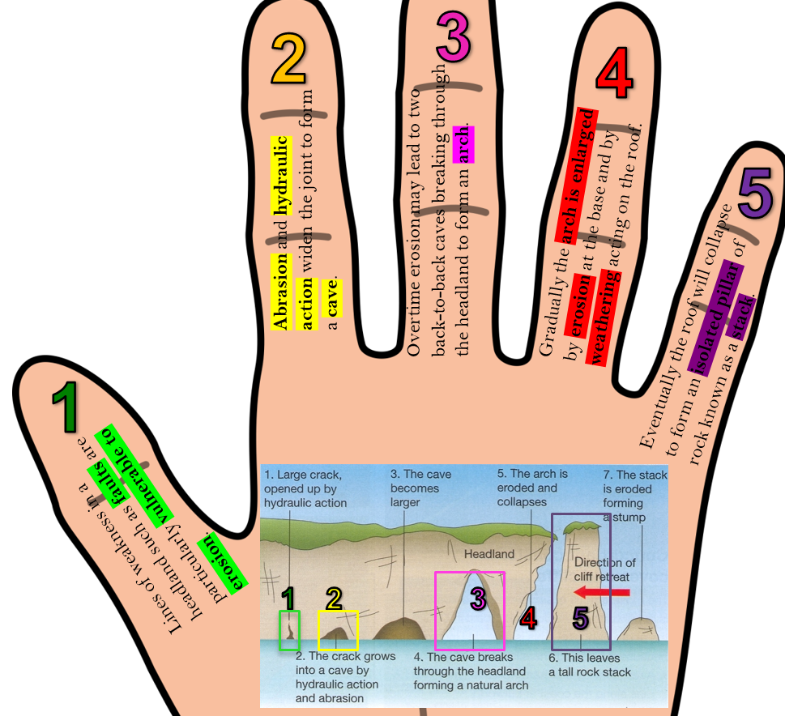 | Sequence – ________________________  __________________________________  __________________________________  Process – _________________________  __________________________________  Explanation – ______________________  __________________________________  __________________________________  __________________________________  __________________________________  __________________________________  __________________________________  Description – ______________________  __________________________________  __________________________________  __________________________________  __________________________________  __________________________________

